**HOW TO INSTALL METAMASK AND USE A TEST NETWORK**

**1.) Install MetaMask to your browser.**

MetaMask is one of the kinds of cryptocurrency wallets that can be used to interact with Web3 applications. Here are the steps to install MetaMask on your browser.

1. Install MetaMask through their official website. (<https://metamask.io/download/>)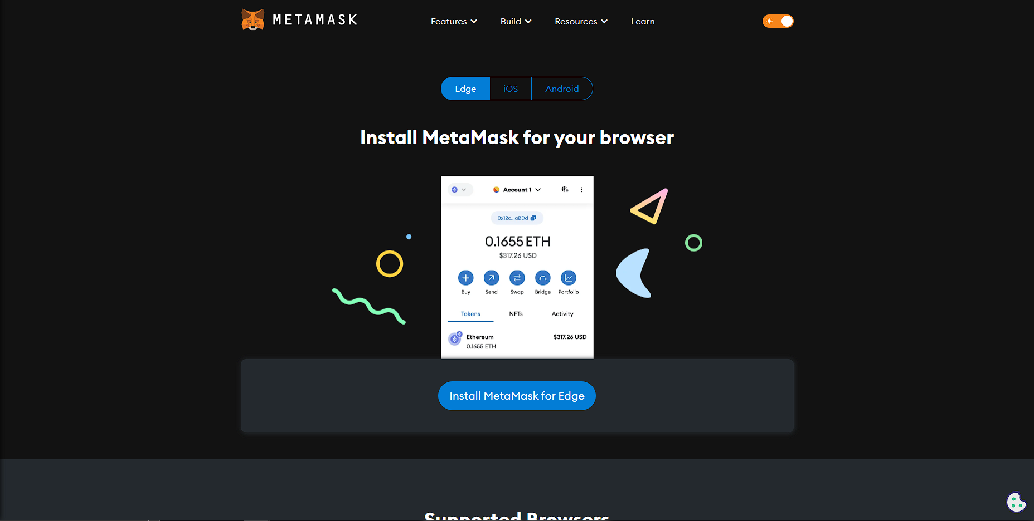
2. Click the Install MetaMask for Chrome/Edge button.
3. After clicking **‘Install’**, you will be redirected to the Microsoft Edge Add-ons/Chrome Web Store. Please click **‘Get’** or **‘Add to Chrome’**.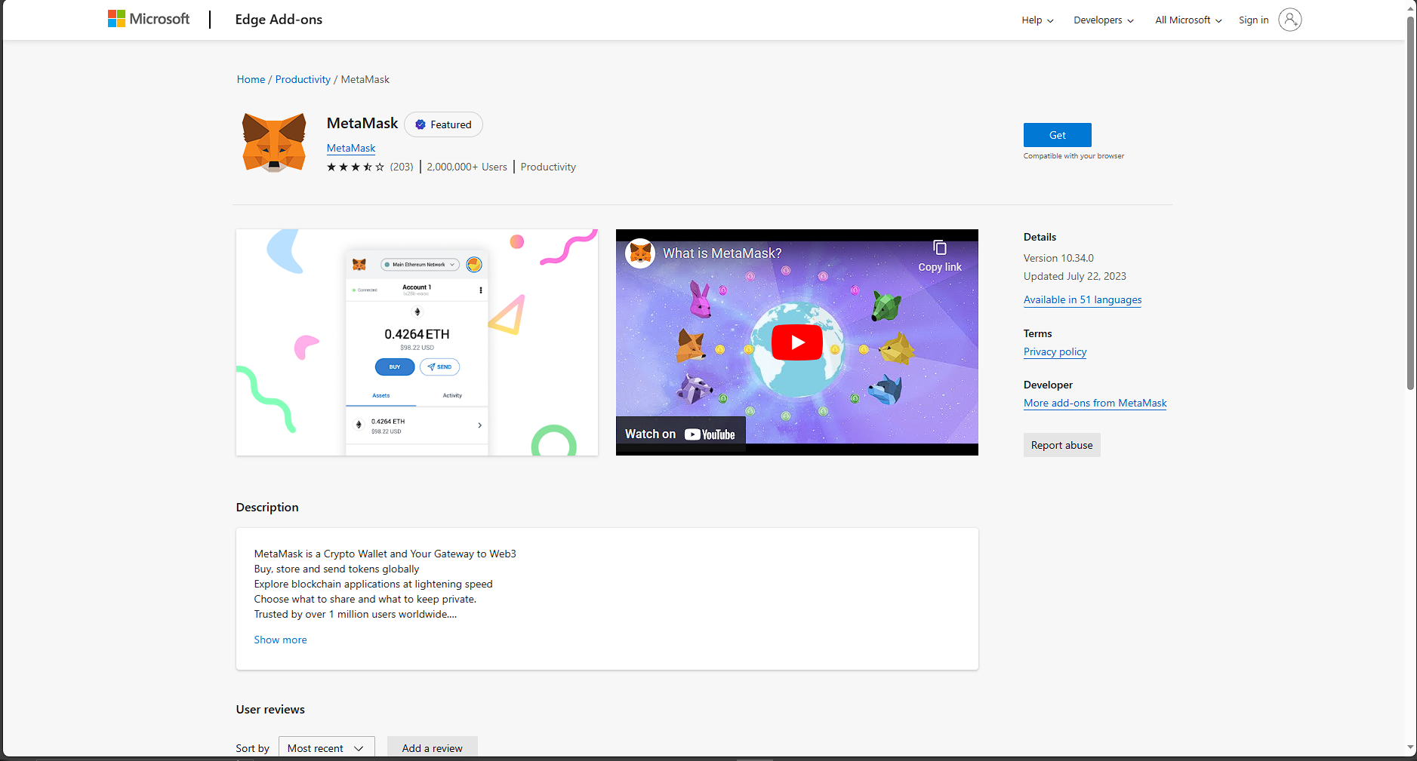
4. Click **‘Add extension’**.  
   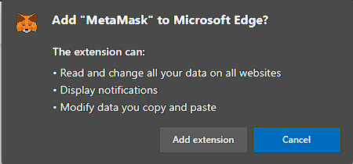
5. Metamask will download and install automatically.
6. Once it is finished, you will be redirected to this page.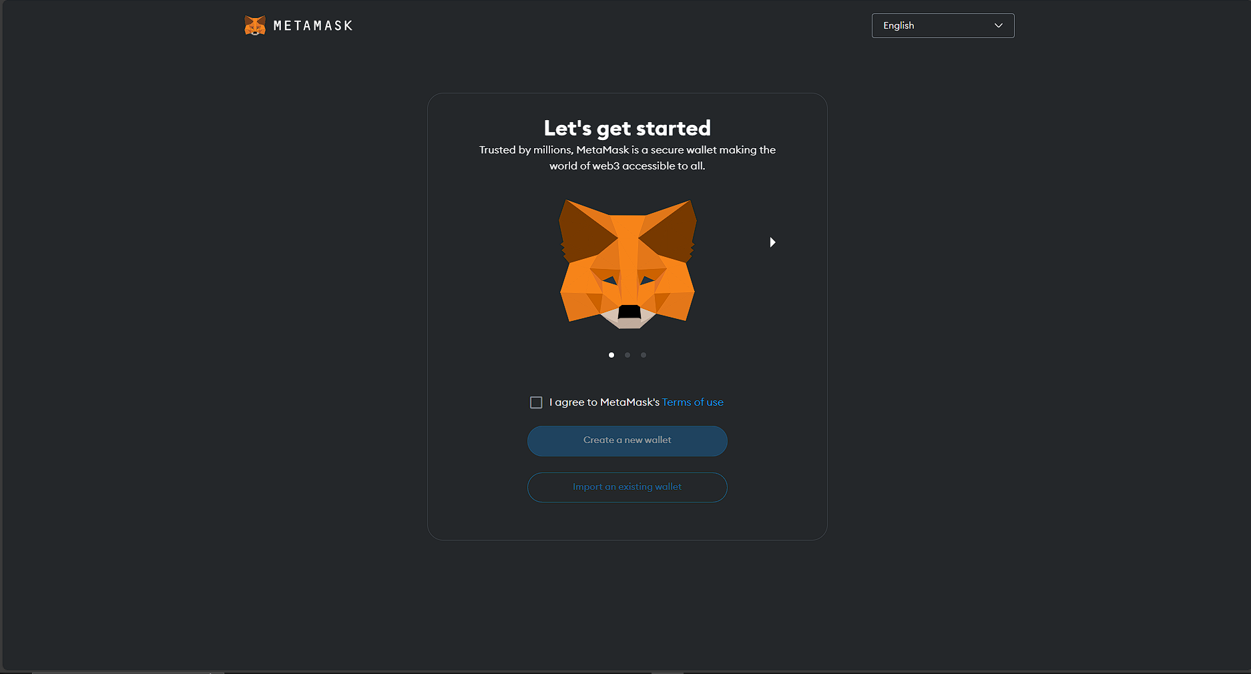

**2.) Creating a MetaMask account.**

1. Click on the **checkbox** beside “I agree to MetaMask’s Terms of use”.
2. Click on **“Create a new wallet”**
3. Click on **“I agree”** and proceed to creating a new wallet.  
   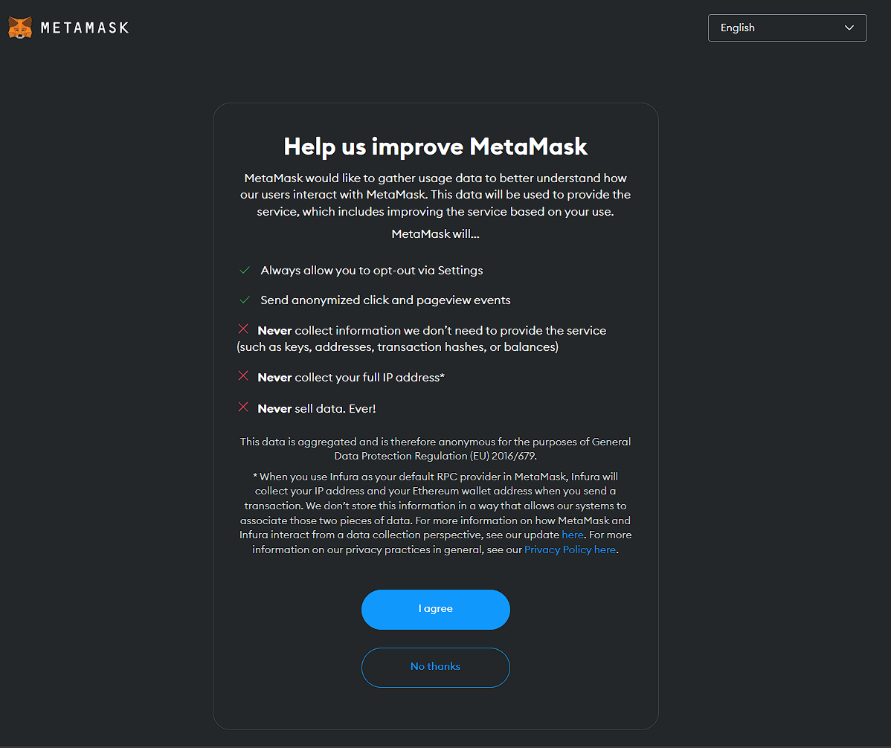
4. Create a strong password.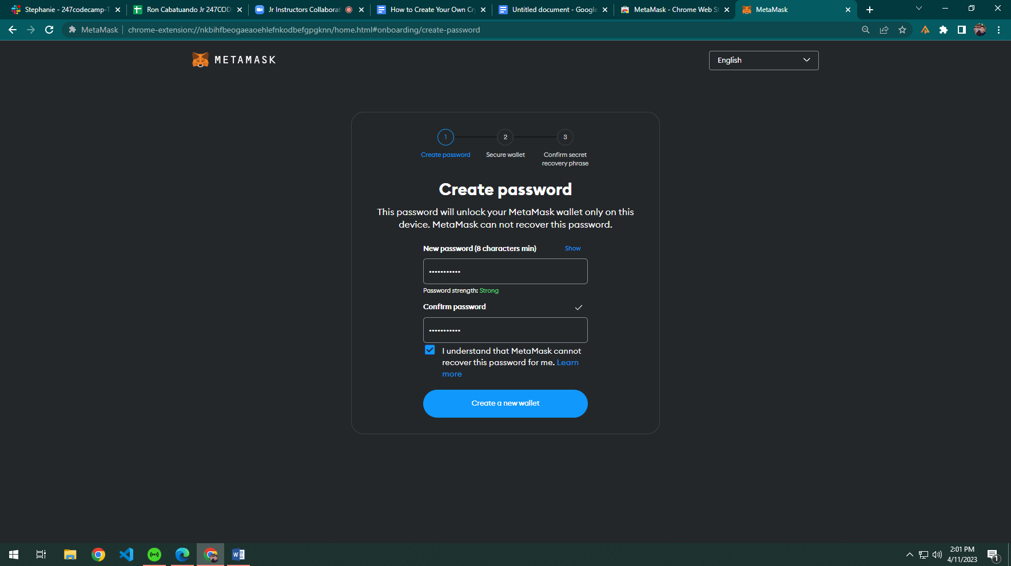
5. Metamask will generate a **12-word secret passphrase**. Store it in a safe place, then click **“Next”**.
6. Confirm the recovery passphrase. Then, the wallet is generated.

**3.) Adding the Mumbai Testnet through MetaMask**

1. Visit the chainlist website: <https://chainlist.org/>   
   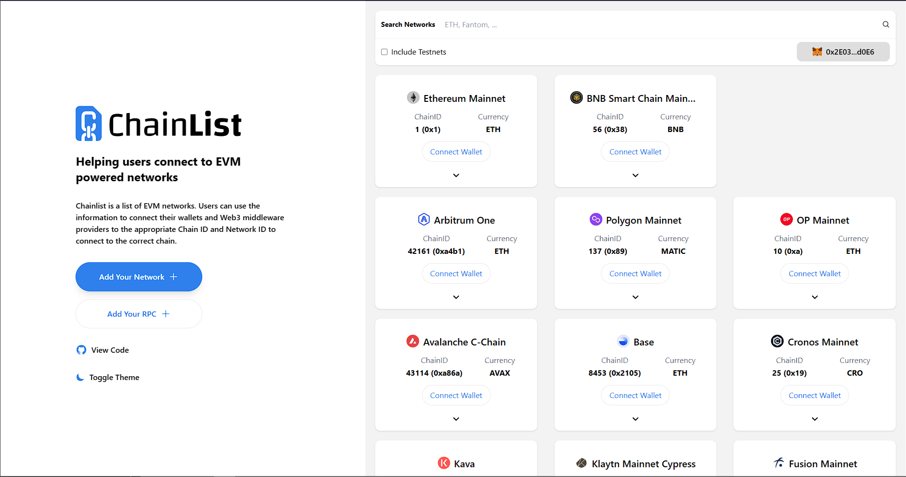
2. Type **“Mumbai”** in the search box, and click the checkbox to include testnets.
3. Click the **“Add to Metamask”** button.  
   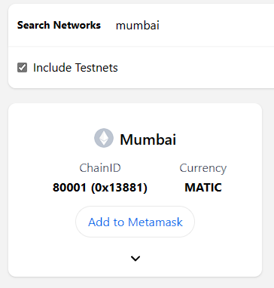
4. A prompt will appear. Click approve to continue the connection.  
   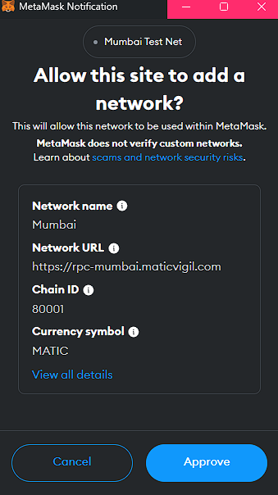
5. You will be asked to switch networks. Click **“Switch Network”**, then you will see that you are connected to the **Mumbai Test Net**.  
   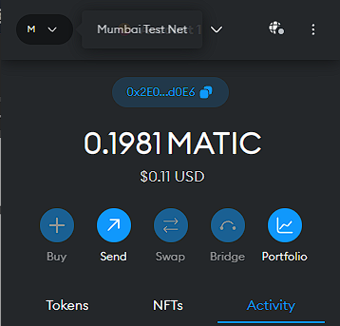
6. To get some **Mumbai (MATIC)** test tokens, go to [Mumbai Faucet](https://mumbaifaucet.com/) and paste your MetaMask public address **(click on the blue pill button starting with 0x)** in the **textbox** (Enter Your Wallet Address (0x...)).  
   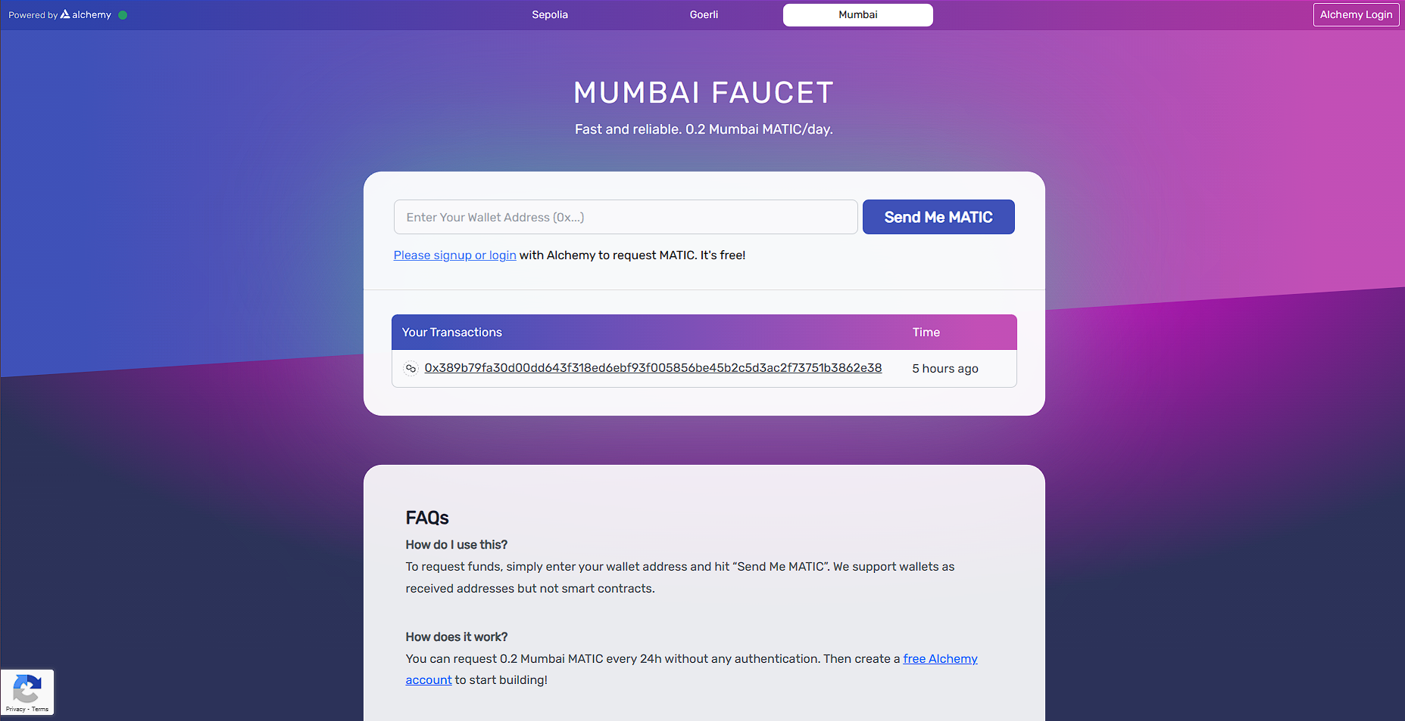
7. Click on **‘Send Me MATIC’** and you’ll be able to receive some test tokens. You now have a mumbai test network along with some MATIC test tokens. Congratulations!